**SQL**  
  
   
30/dec/2025  
Q1:  
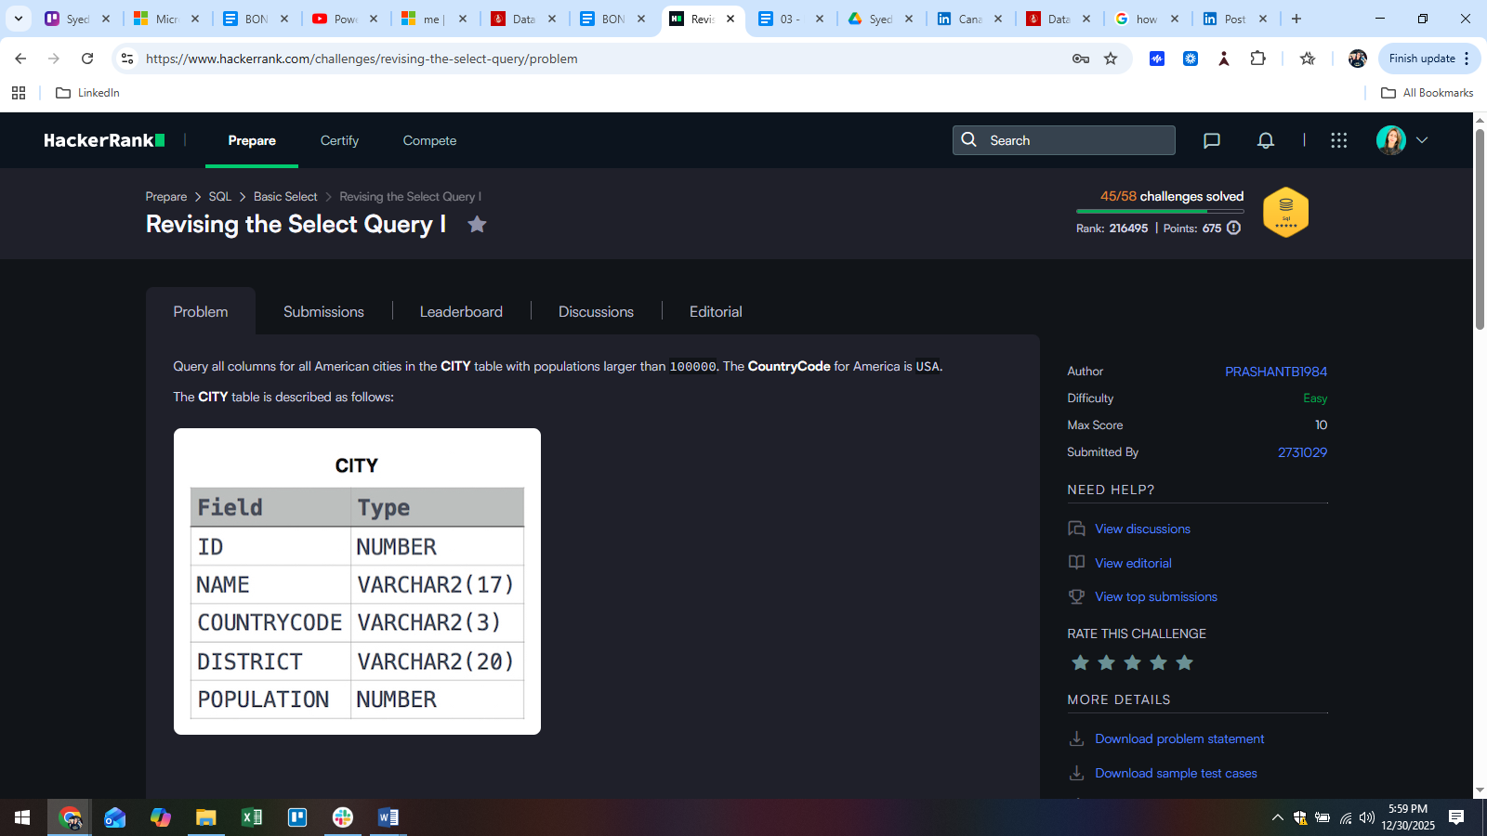  
  
Answer:   
SELECT *

FROM CITY

WHERE COUNTRYCODE = "USA" AND POPULATION > 100000;

Q2:  
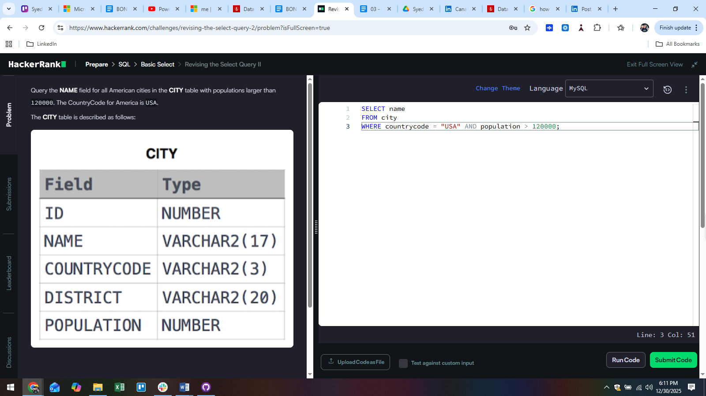

Answer:  
SELECT name

FROM city

WHERE countrycode = "USA" AND population > 120000;

Q3:  
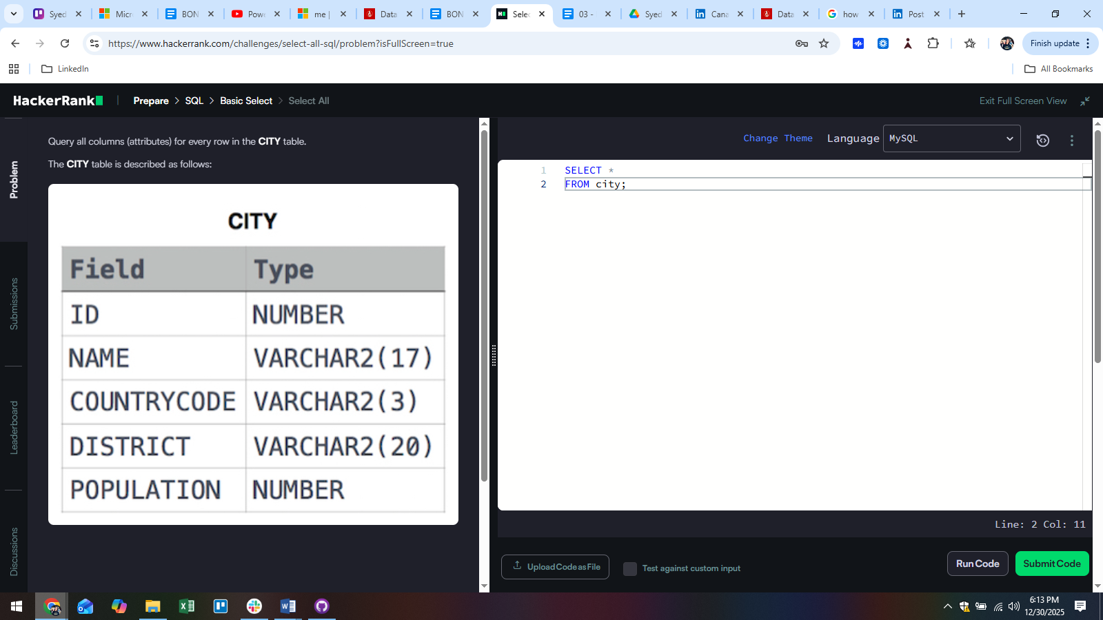  
  
Answer:   
SELECT *

FROM city;

Q4:  
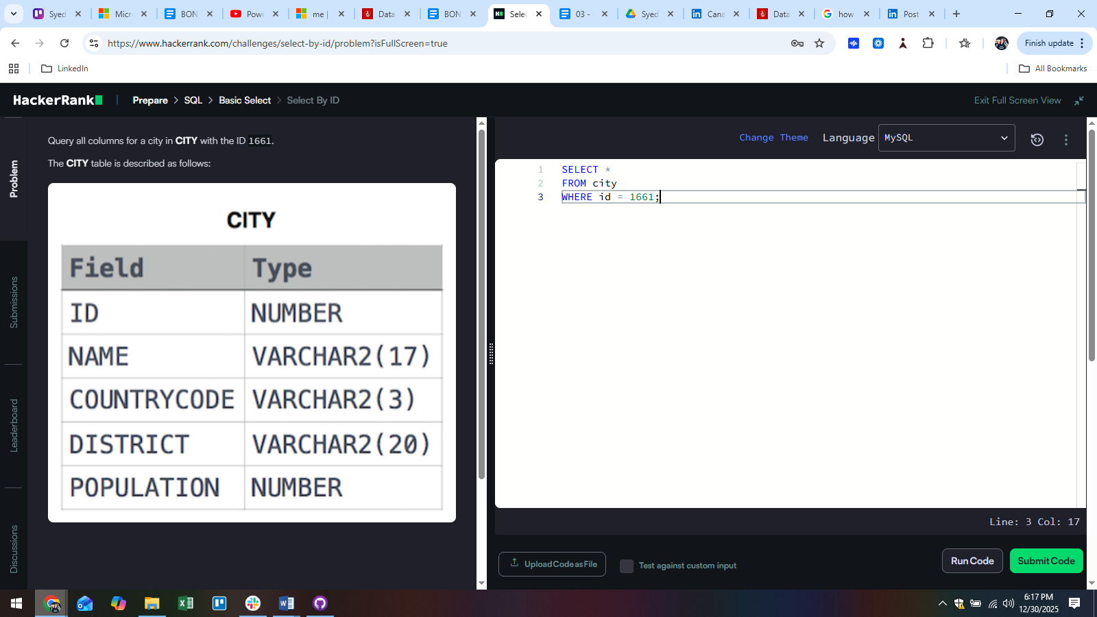

Answer:  
SELECT *

FROM city

WHERE id = 1661;

Q5:  
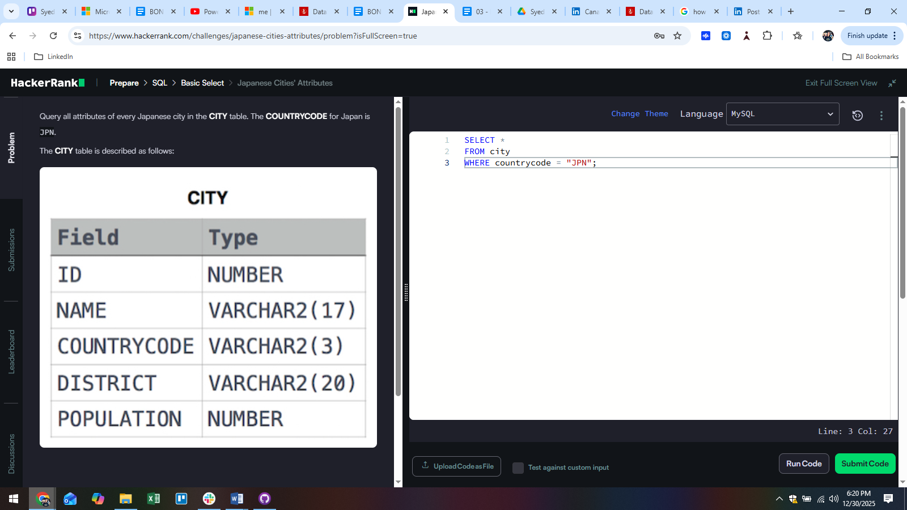

Answer:  
SELECT *

FROM city

WHERE countrycode = "JPN";

31/dec/2025  
Q6:  
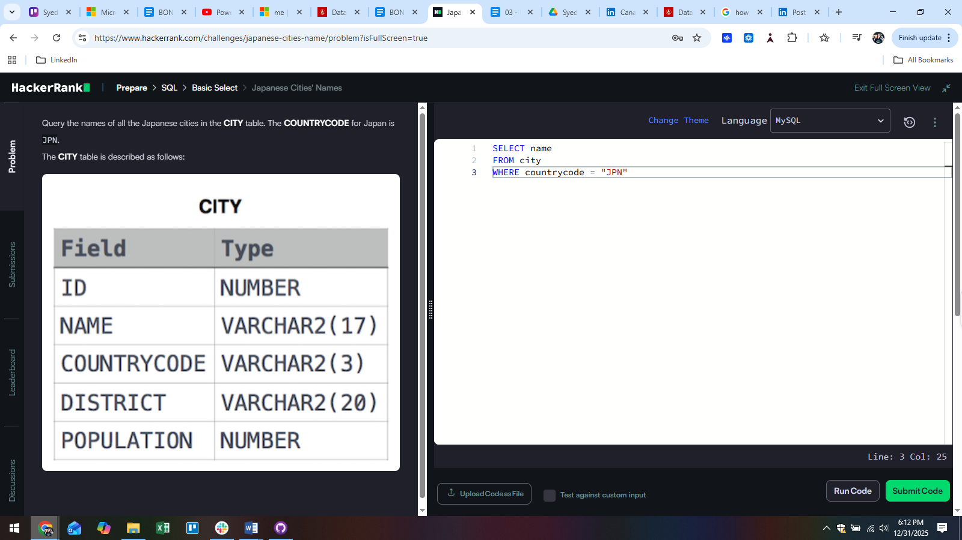  
  
Answer:  
SELECT name

FROM city

WHERE countrycode = "JPN"

Q7:  
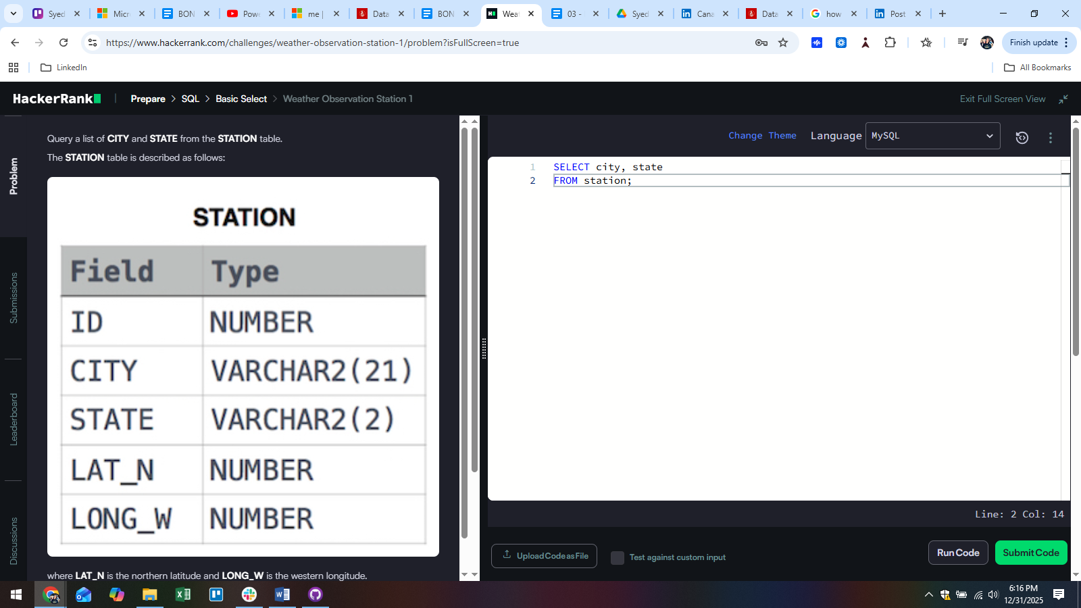

Answer:  
SELECT city, state

FROM station;

Q8:  
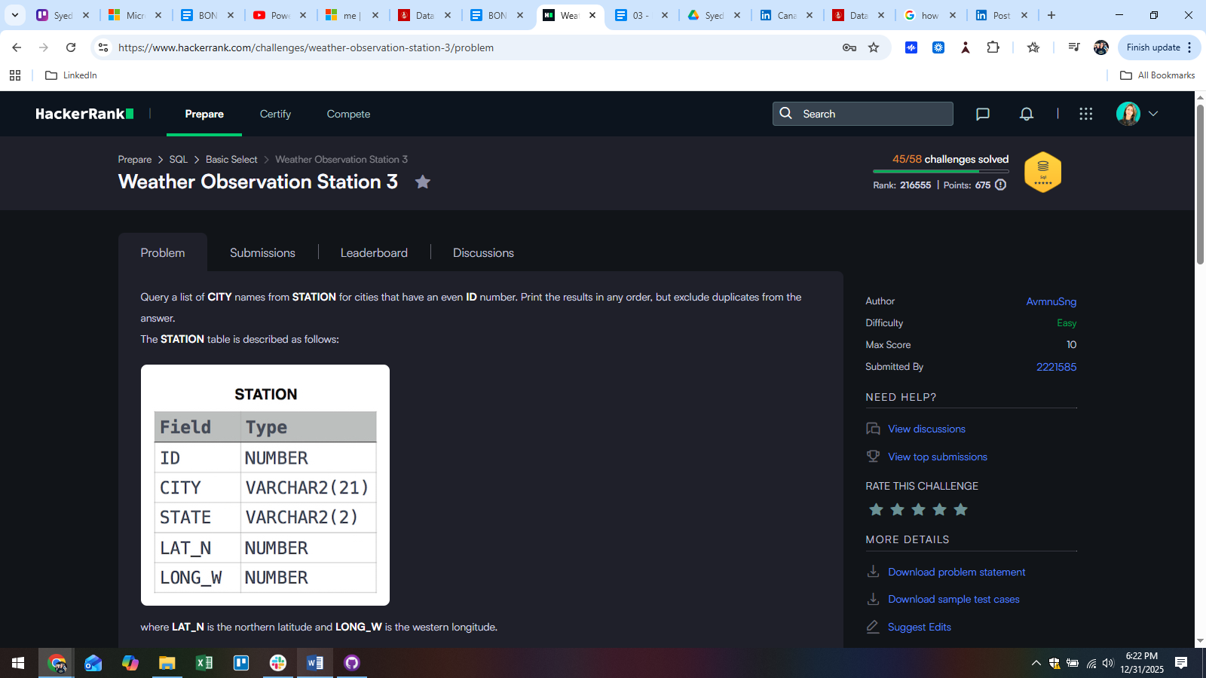

Answer:  
SELECT DISTINCT(city)

FROM station

WHERE id%2 = 0;

Q9:  
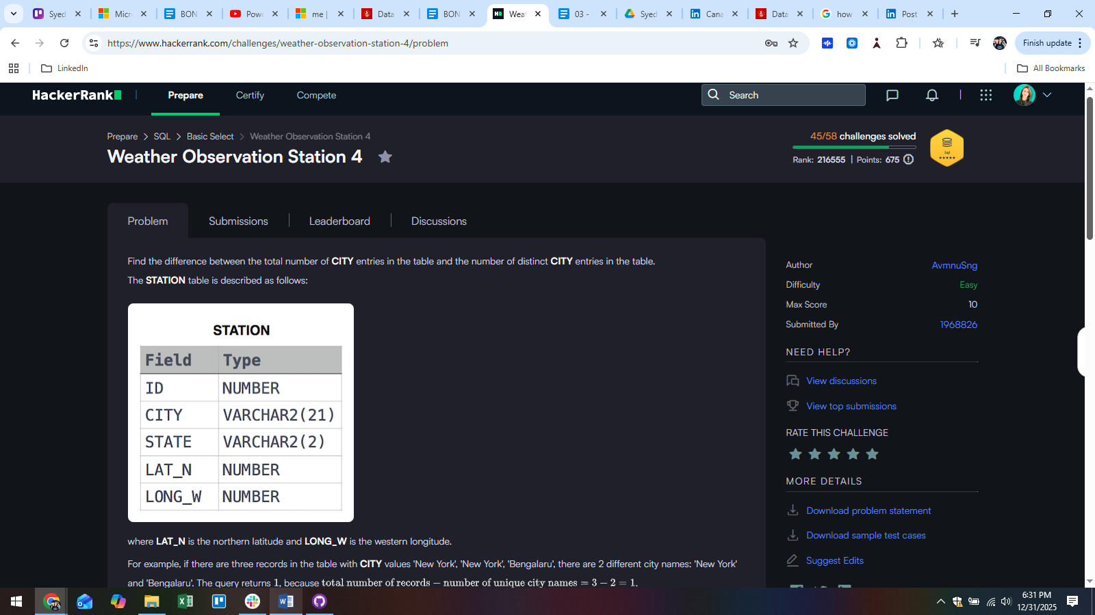

Answer:  
SELECT COUNT(city) - COUNT(DISTINCT(city))

FROM station;

Q10:  
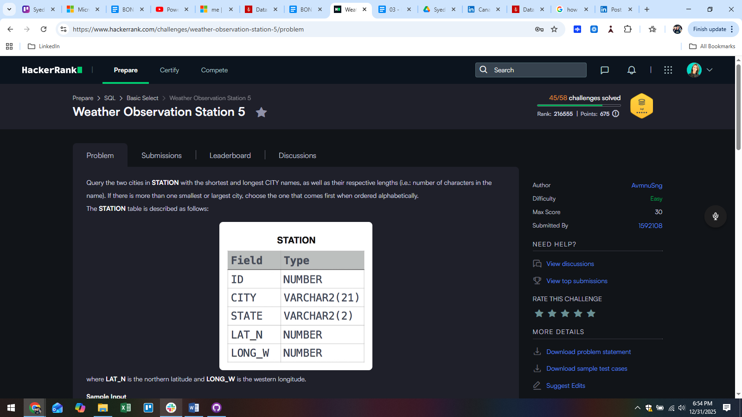

Answer:  
SELECT city, LENGTH(city)

FROM station

ORDER BY LENGTH(city), city LIMIT 1 ;

SELECT city, LENGTH(city)

FROM station

ORDER BY LENGTH(city) DESC, city LIMIT 1 ;

02/Jan/2026  
Q11:  
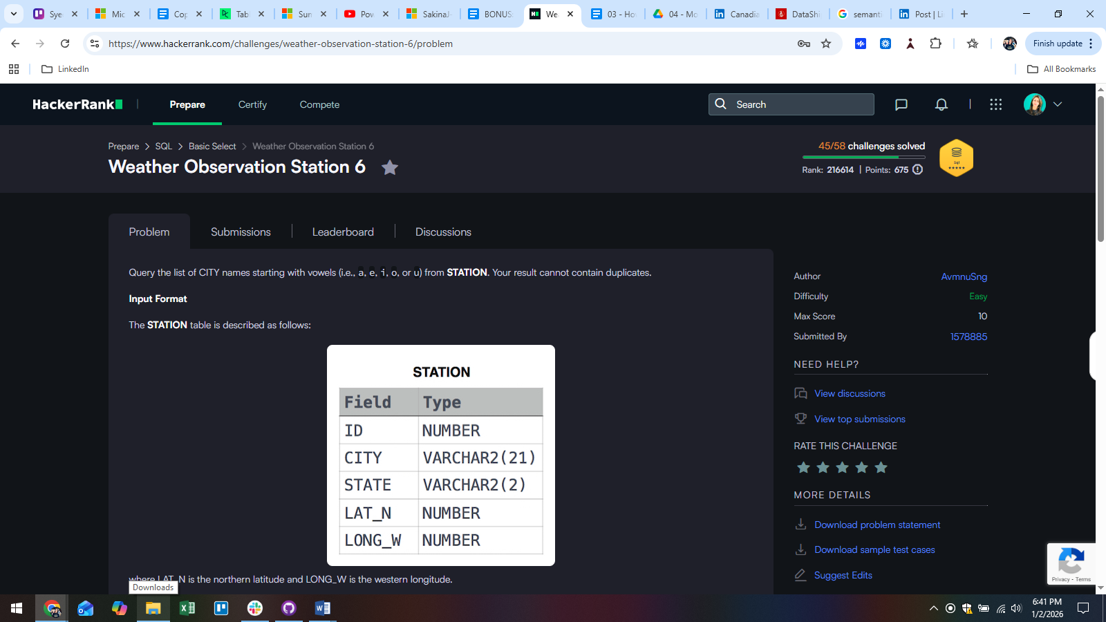

Answer:  
SELECT DISTINCT(city)

FROM station

WHERE LEFT(LOWER(city), 1) IN ('a', 'e', 'i', 'o', 'u');

Q12:  
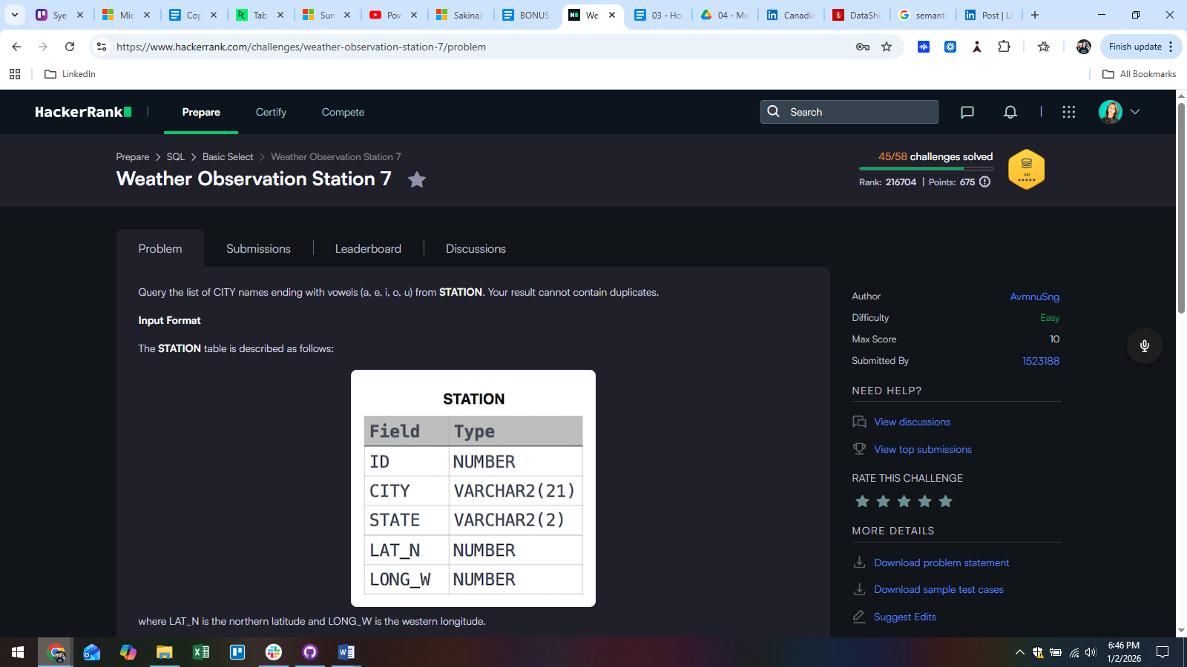

Answer:  
SELECT DISTINCT(city)

FROM station

WHERE RIGHT(LOWER(city),1) IN ('a', 'e', 'i', 'o', 'u');

Q13:  
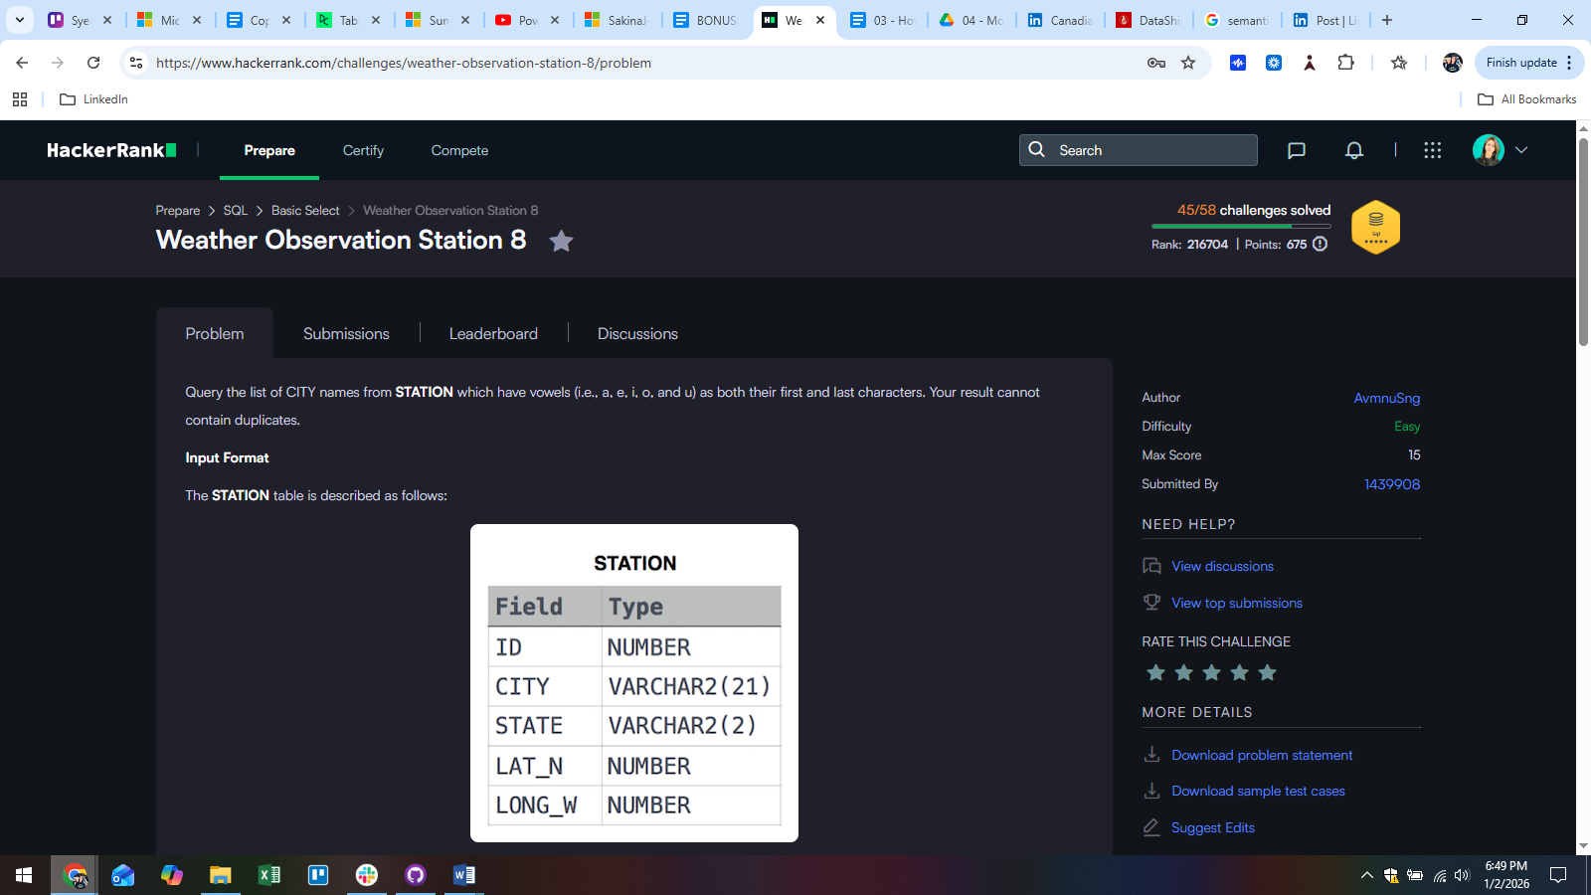

Answer:  
SELECT DISTINCT(city)

FROM station

WHERE LEFT(LOWER(city),1) IN ('a', 'e', 'i', 'o', 'u')

AND RIGHT(LOWER(city),1) IN ('a', 'e', 'i', 'o', 'u');

Q14:  
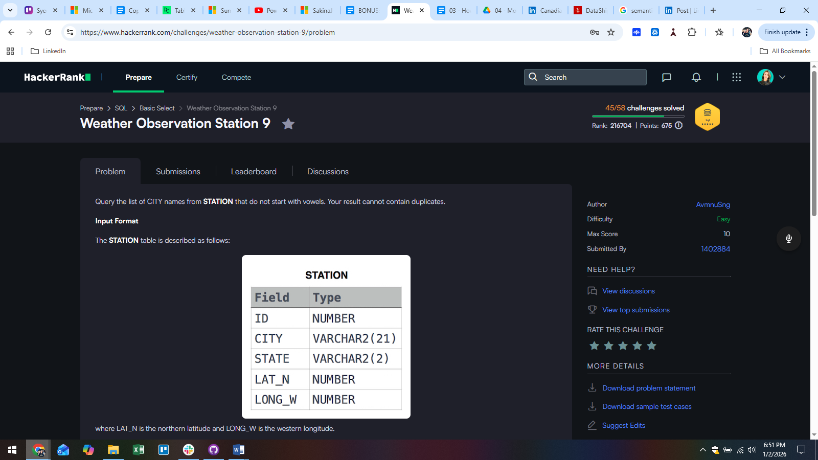

Answer:  
SELECT DISTINCT(city)

FROM station

WHERE LEFT(LOWER(city),1) NOT IN ('a', 'e', 'i', 'o', 'u') ;

Q15:  
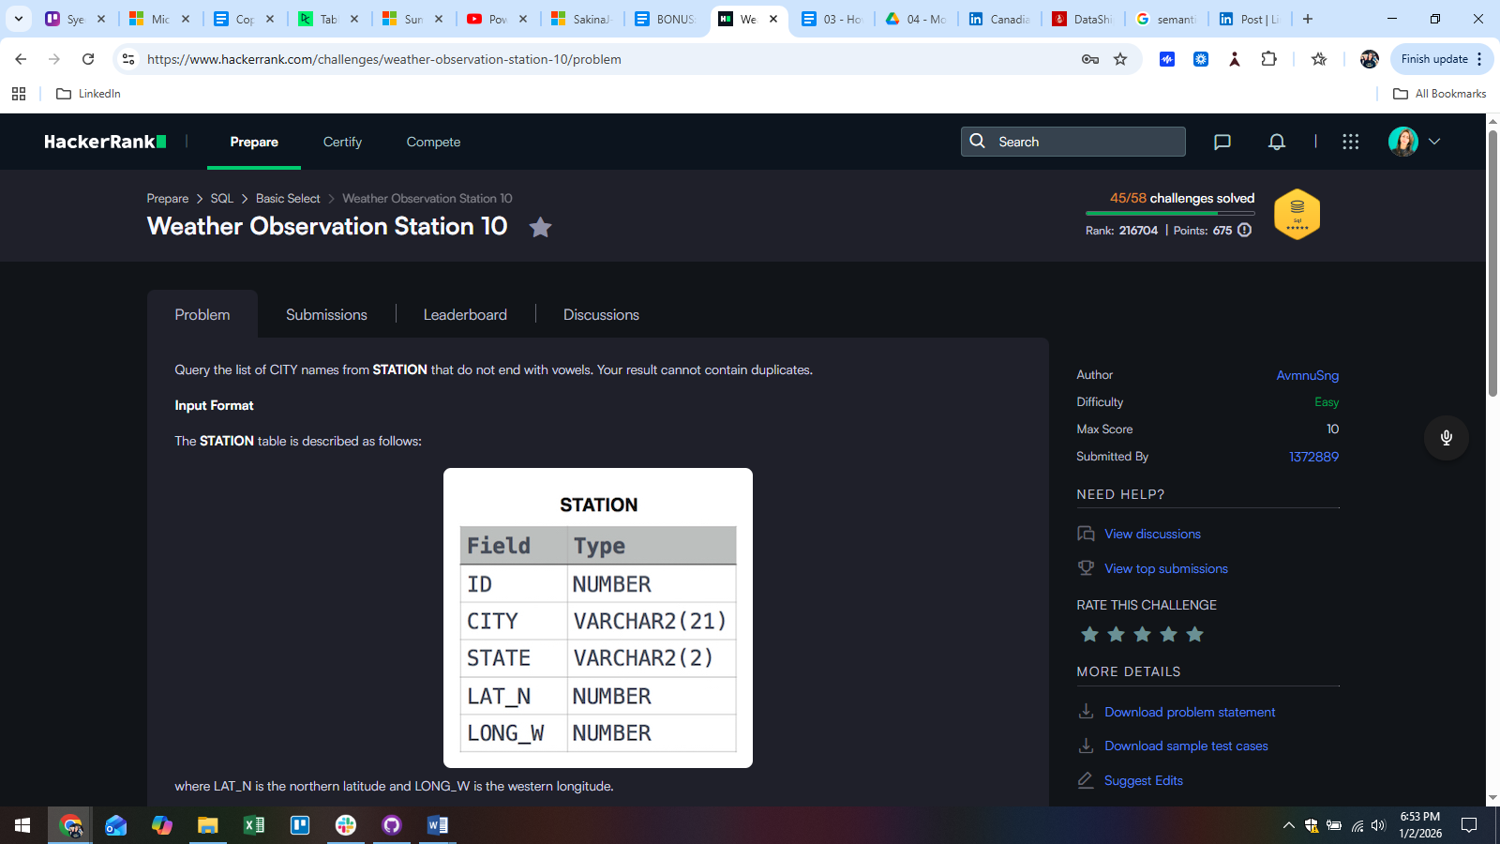

Answer:  
SELECT DISTINCT(city)

FROM station

WHERE RIGHT(LOWER(city),1) NOT IN ('a', 'e', 'i', 'o', 'u') ;

04/jan/2026  
Q16:  
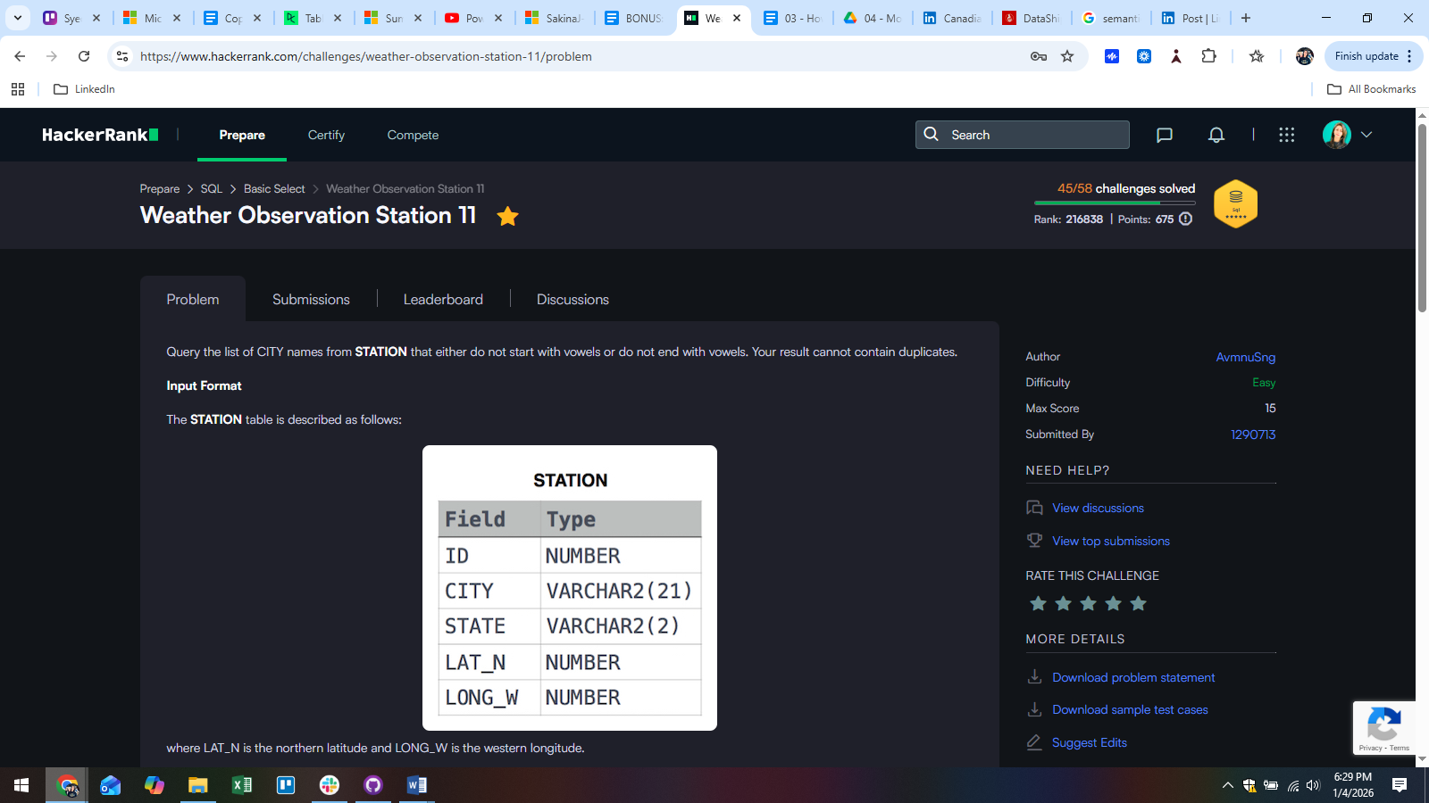

Answer:  
SELECT DISTINCT(city)

FROM station

WHERE RIGHT(city,1) NOT IN ('a', 'e', 'i', 'o', 'u')

OR LEFT(city,1) NOT IN ('a', 'e', 'i', 'o', 'u');

Q17:  
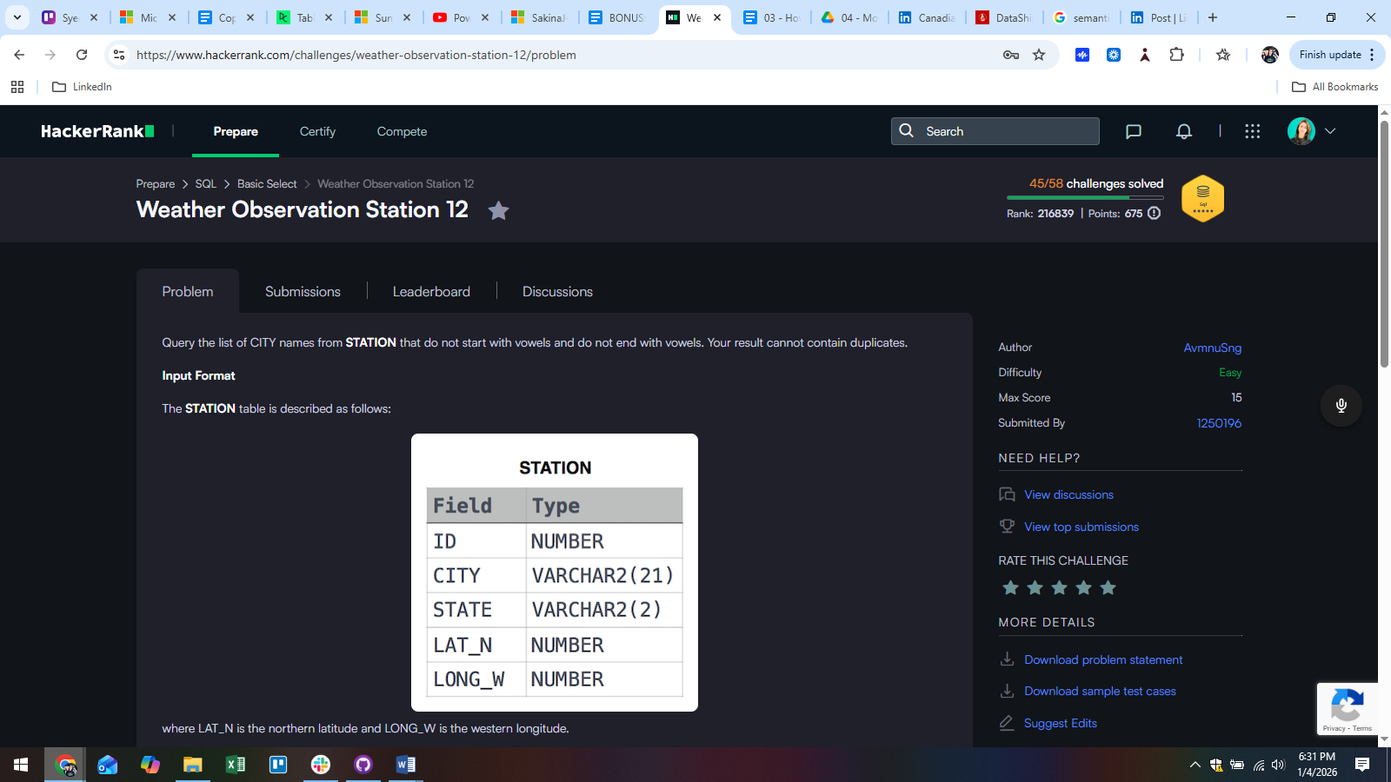

Answer:  
SELECT DISTINCT(city)

FROM station

WHERE RIGHT(city,1) NOT IN ('a', 'e', 'i', 'o', 'u')

AND LEFT(city,1) NOT IN ('a', 'e', 'i', 'o', 'u');

Q18:

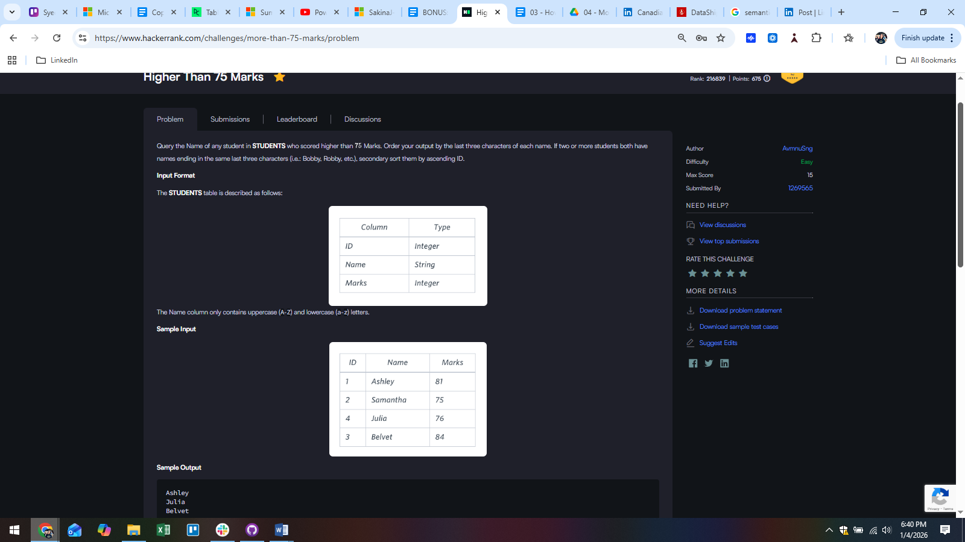

Answer:  
SELECT name

FROM students

WHERE marks > "75"

ORDER BY RIGHT(name,3) , id ASC;

Q19:  
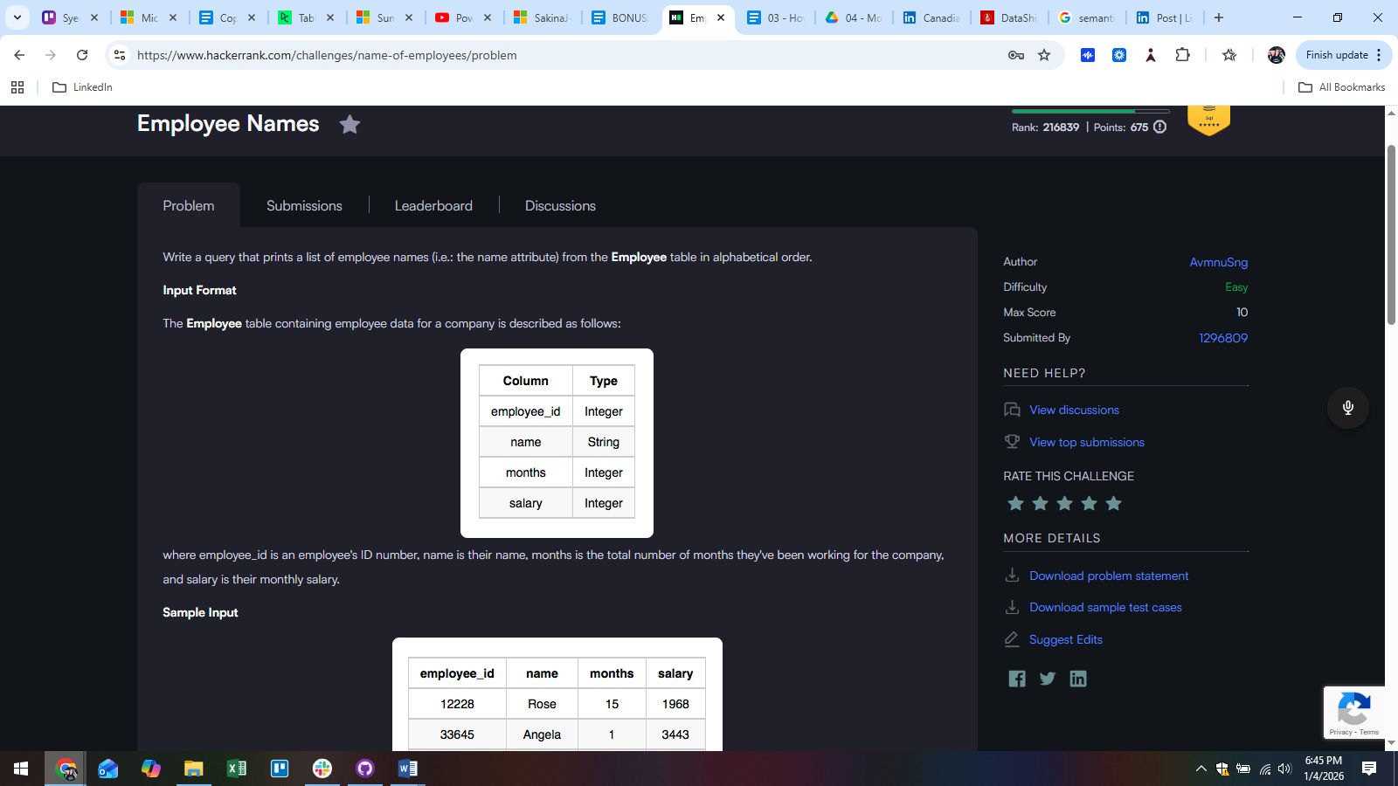

Answer:  
SELECT name

FROM employee

ORDER BY name ASC;

Q20:

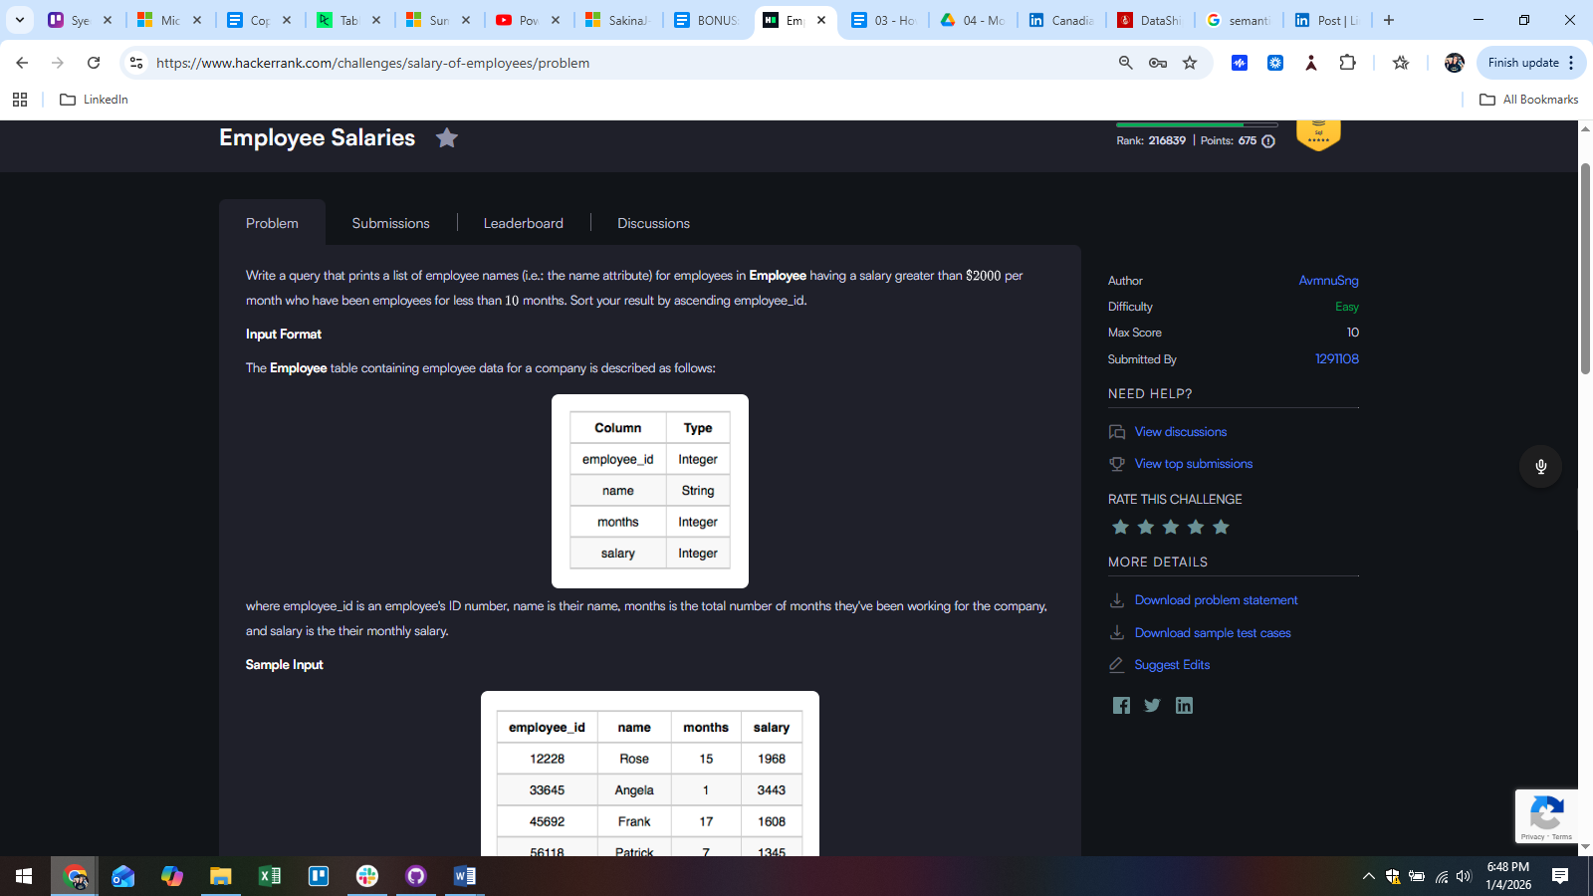  
Answer:  
SELECT name

FROM employee

WHERE salary > "2000"

AND months < "10"

ORDER BY employee_id ASC;